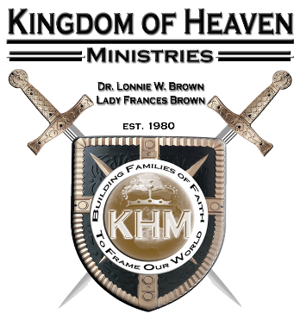

KHM’s Perfecting Class
Lesson 2:
The Promise and Power of the Holy Spirit

Lesson Assignment: Watch the video online. Go over the lesson in its entirety. Be sure to read carefully all the scripture references. Finish the Lesson Quiz online at the bottom of the lesson. When done with the quiz click the send button to upload it to your instructor.

Lesson Objective:
To provide a brief introduction to purpose of the indwelling presence of the Holy Spirit in the life of the believer.

- The Promise of the Holy Spirit
- Old Testament Promise (Joel 2:28-29)
- New Testament Promise (John 7:37-39; 14:16)
- New testament Fulfillment (Acts 2:4)

Scripture References: Joel 2:28-29, John 7:37-39, Acts 2:4 KJV

Joel 2:28 And it shall come to pass afterward, that I will pour out my spirit upon all flesh; and your sons and your daughters shall prophesy, your old men shall dream dreams, your young men shall see visions:
Joel 2:29 And also upon the servants and upon the handmaids in those days will I pour out my spirit.
John 7:37 In the last day, that great day of the feast, Jesus stood and cried, saying, If any man thirst, let him come unto me, and drink.
John 7:38 He that believeth on me, as the scripture hath said, out of his belly shall flow rivers of living water.
John 7:39 (But this spake he of the Spirit, which they that believe on him should receive: for the Holy Ghost was not yet given; because that Jesus was not yet glorified.)
John 14:16 And I will pray the Father, and he shall give you another Comforter, that he may abide with you for ever;
Act 2:2 And suddenly there came a sound from heaven as of a rushing mighty wind, and it filled all the house where they were sitting.
Act 2:3 And there appeared unto them cloven tongues like as of fire, and it sat upon each of them.
Act 2:4 And they were all filled with the Holy Ghost, and began to speak with other tongues, as the Spirit gave them utterance.

- The Holy Spirit gives us power to live this Christian life (Acts 1:8, Ephes 3:20)

Scripture References: Joel 2:28-29, John 7:37-39, Acts 2:4 KJV

Act 1:8 But ye shall receive power, after that the Holy Ghost is come upon you: and ye shall be witnesses unto me both in Jerusalem, and in all Judaea, and in Samaria, and unto the uttermost part of the earth.
Eph 3:20 Now unto him that is able to do exceeding abundantly above all that we ask or think, according to the power that worketh in us,

- The Baptism on the Holy Spirit
- Jesus in the one who baptizes us in the Holy Spirit (Luke 3:16)
- The Baptism in the Holy Spirit usually occurs after you are Born Again (Acts 19:2)
- The Baptism in the Holy Spirit differs from the water Baptism (Acts 19:3-6)

Scripture References: Acts 19:2-6 KJV

Act 19:2 He said unto them, Have ye received the Holy Ghost since ye believed? And they said unto him, We have not so much as heard whether there be any Holy Ghost.
Act 19:3 And he said unto them, Unto what then were ye baptized? And they said, Unto John's baptism.
Act 19:4 Then said Paul, John verily baptized with the baptism of repentance, saying unto the people, that they should believe on him which should come after him, that is, on Christ Jesus.
Act 19:5 When they heard this, they were baptized in the name of the Lord Jesus.
Act 19:6 And when Paul had laid his hands upon them, the Holy Ghost came on them; and they spake with tongues, and prophesied.

- Speaking in Tongues (The evidence of the Baptism)
- Tongues as the initial sign (Acts 2:4, 10:44-46, 19:4-6)

- The Benefit of Speaking in Tongues:
- Out of your belly flows rivers of living water (John 7:38)
- You give thanks well. (ICor. 14:17)
- You build yourself up on your most Holy faith. (Jude 1:20)
- You Speak Spiritual mysteries. (ICor. 14:2)

